VIET NAM NATIONAL UNIVERSITY HO CHI MINH CITY
UNIVERSITY OF ECONOMICS AND LAW
FACULTY OF ACCOUNTING AND AUDITING

MIDTERM REPORT
Data Analytics in Accounting and Auditing

AUDIT CLIENT ACCEPTANCE
ASSESSMENT OF COMPANY X
An analysis of 2024 accounting records using Audit.py
Lecturer Msc. Duong Trong Nhan
Prepared by Student ID
1. Nguyen Tan Loc K234050654
2. Nguyen Hung K234050653
3. Nguyen Thuy Khanh Binh K234050643
4. Dang Hoang Thanh Thuy K234050668
5. Dao Nguyen Minh Thao K234050664
Class K23405E Group 5
Ho Chi Minh City, November 2026

TABLE OF CONTENTS
LIST OF ABBREVIATIONS ii
LIST OF TABLES iii
LIST OF FIGURES iii
INTRODUCTION 1
CHAPTER 1. DATA AND METHODS 2
CHAPTER 2. DATA INTEGRITY 3
2.1. Reconciliation of account balances and period totals 3
CHAPTER 3. JOURNAL ENTRY TESTING 5
3.1. Exceptions requiring priority review 6
3.2. First-digit analysis using Benford's law 7
CHAPTER 4. GENERAL LEDGER AND FINANCIAL STATEMENTS 8
4.1. Financial performance and closing entries 9
4.2. Monthly financial performance 10
CHAPTER 5. PRELIMINARY MATERIALITY 11
CHAPTER 6. FINANCIAL ANALYSIS 12
6.1. Liquidity, efficiency and profitability 13
6.2. Operating cash flow and the accruals ratio 14
6.3. Interest coverage and the Altman Z″ score 15
CHAPTER 7. DATA VISUALISATION 16
CHAPTER 8. AUDIT CLIENT ACCEPTANCE ASSESSMENT 17
8.1. Decision override criteria and sensitivity analysis 18
8.2. Conditions for acceptance and proposed audit procedures 18
CONCLUSION 20
REFERENCES 21
APPENDIX A. OUTPUT FILES AND REPRODUCIBILITY 22
APPENDIX B. SOURCE CODE ORGANISATION 23
LIST OF ABBREVIATIONS
Abbreviation | Meaning
FS | Financial statements
Dr, Cr | Debit, credit
CA, NCA | Current assets, non-current assets
COGS | Cost of goods sold
PBT, PAT | Profit before tax, profit after tax
JE | Journal entry (JE01 to JE10 identify the screening procedures)
CFO | Net cash from operating activities
EBIT | Earnings before interest and tax
DSO, DIO, DPO | Days sales outstanding, days inventory outstanding, days payable outstanding
CCC | Cash conversion cycle
ROA, ROE | Return on assets, return on equity
SD, MAD, IQR | Standard deviation, mean absolute deviation, interquartile range
OOP, FP | Object-oriented programming, functional programming
VSA | Vietnamese Standards on Auditing
LIST OF TABLES
Table 1.1. Sources of accounting data for 2024 2
Table 2.1. Integrity checks on the detailed ledger 3
Table 2.2. Reconciliation of the detailed ledger and trial balance 4
Table 3.1. Screening results by procedure and priority 5
Table 3.2. Results of the Benford analysis 7
Table 4.1. Condensed balance sheet (VND billion) 8
Table 4.2. Condensed income statement (VND billion) 9
Table 5.1. Overall materiality under alternative benchmarks 11
Table 5.2. Materiality and the threshold for clearly trivial misstatements 11
Table 6.1. Financial indicators and screening thresholds 12
Table 6.2. Reconciliation of changes in cash balances (VND billion) 14
Table 6.3. Inputs to the Altman Z″ score 15
Table 8.1. Risk scores, weights and contributions 17
Table 8.2. Assessment of the decision override criteria 18
Table 8.3. Sensitivity analysis across 15 scenarios 18
Table 8.4. Required evidence and audit procedures 19
Table A.1. Output files by module 22
Table B.1. Programming techniques used in Audit.py 23
LIST OF FIGURES
Figure 3.1. Ledger line items by day of the week 6
Figure 3.2. Observed and expected first-digit frequencies 7
Figure 4.1. Composition of assets, liabilities and equity 8
Figure 4.2. Monthly net revenue, cost of goods sold and gross profit 10
Figure 4.3. Monthly gross margin and reference interval 10
Figure 7.1. Distribution of ledger line amounts 16
Figure 7.2. Distribution of ledger line amounts by account class 16
Figure 8.1. Overall risk score and decision ranges 17

INTRODUCTION
Before accepting an audit engagement, the audit firm assesses the prospective client and considers whether it has the resources and competence to perform the audit. This report examines whether UEL-Audit should accept an engagement to audit Company X's financial statements. It uses the company's 2024 accounting records to identify matters that bear on the acceptance decision [1,3].
The analysis uses the detailed accounting ledger and trial balance for the year ended 31 December 2024. Audit.py, developed for this project, reconciles the records, screens journal entries, prepares condensed financial statements and calculates financial ratios. Preliminary materiality guides the prioritisation of exceptions. The assessment groups the results into five risk categories and examines how changes in weights and decision thresholds affect the recommendation.
The data integrity checks flagged 7,227 of the 100,626 ledger line items for review. Net revenue was VND 475.602 billion and profit after tax per the ledger was VND 11.322 billion. The overall risk score of 56.00 out of 100 falls within the project's range for conditional acceptance. Chapter 8 sets out the matters to resolve before approving the engagement.

CHAPTER 1. DATA AND METHODS
Table 1.1. Sources of accounting data for 2024
Source | Content and purpose
Detailed accounting ledger  (D1) | SO CHI TIET 01.01-31.12.2024.xlsx contains 35 columns and 100,879 rows below the header. It is used to check ledger line items and total debits and credits by account.
Trial balance  (D2) | BANG CAN DOI PS TK 01.01-31.12.2024.xlsx contains opening balances, debits and credits for the period, and closing balances. It provides the reference for reconciling results derived from D1.
Unit of analysis
Each line item in the detailed accounting ledger (D1) shows a debit or credit to an account. A journal entry can comprise several lines. For example, a receipt from a customer debits bank account 112 and credits trade receivables account 131. The balance check groups the lines using the available voucher identifiers.
D1 also contains opening and closing balance rows and total rows. These rows are separated from journal entry line items before debits and credits for the period are totalled. Each standardised record retains the source filename, worksheet and row number for tracing exceptions back to the ledger.
Data preparation and calculation conventions
Testing used standardised column names and data types. Calculations use decimal arithmetic, with account codes stored as text to preserve leading zeros. The prepared dataset distinguishes blank cells from zeros and retains unused fields.
Amounts in the source files are in Vietnamese dong (VND). Where indicated, tables and figures present amounts in billions of VND. Calculations and reconciliations use unrounded amounts. Differences are recorded with their source references.
The configuration specifies how accounts are mapped to financial statement line items and records assumptions about liability maturities and screening thresholds. Running main.py reruns the analysis from the two source files. The chart of accounts for the 2024 data is based on Circular 200/2014/TT-BTC, as amended [2]. Circular 99/2025/TT-BTC applies to financial years beginning on or after 1 January 2026 [4].

CHAPTER 2. DATA INTEGRITY
The data integrity checks covered dates, identifiers and amounts for individual ledger line items. Where identifiers allowed lines to be grouped by voucher, the checks also tested whether total debits equalled total credits within each group.
Table 2.1. Integrity checks on the detailed ledger
Check | Result | Scope and definition
Rows below the header | 100,879 | Includes journal entry line items, balance rows and total rows.
Lines included in analysis | 100,626 | Comprises 100,624 lines provisionally classified as transactions and two lines whose type remains uncertain.
Period coverage | All 12 months | Observed posting dates fall within 2024.
Lines requiring review | 7,227 | Each line is counted once, even if it carries several flags.
Missing identifiers | 128 voucher numbers  2 account codes | Missing information needed to group vouchers or identify accounts.
Negative / zero amounts | 5,156 / 1,579 | Includes items that may represent reversals or adjustments.
Posting and voucher dates more than 30 days apart | 376 lines | Absolute difference between the posting date and the voucher date.
Unbalanced voucher groups | 35 groups | Difference between total debits and credits within a group.
Total debits and total credits for the period were VND 4,549,575,320,108.53234660 and VND 4,549,575,320,108.56742510, respectively. Debits less credits amounted to −VND 0.03507850. The reconciliation uses a zero tolerance for differences, so the amount was retained for follow-up.
Of the 17,124 voucher groups, 17,087 balanced, 35 had unequal debit and credit totals, and two balanced but had missing account information. A further 128 lines lacked voucher numbers and were tracked separately. The count of 7,227 refers to distinct lines flagged for review, as a line may fail more than one check.

2.1. Reconciliation of account balances and period totals
The reconciliation compared debit and credit totals by account in D1 with those in the trial balance (D2). Where subaccounts existed, the comparison used the appropriate level of the account hierarchy to avoid counting both a parent account and its subaccounts.
D2 has 146 rows covering 134 distinct account codes. Twelve codes appear twice with identical amounts. The reconciliation used one set of figures per code and retained both source row references. Summing the 43 top-level accounts reproduced the six trial balance totals for opening balances, period debits and credits, and closing balances.
Table 2.2. Reconciliation of the detailed ledger and trial balance
Reconciliation scope | Result | Interpretation
Debits and credits by account | 102 matched, 19 differed,  13 had no entries and  1 lacked a reference | Differences were below VND 0.001 on each side.
Balances and source totals | 663 matched, 48 differed and  4 could not be reconciled | Opening balances, closing balances and roll-forwards were checked separately.
Chart of accounts checks | 9 account code flags  9 corresponding account code flags | Fields were counted separately. Both flags may occur on the same line.
Reconciliation of account 13311
Account 13311 has an opening debit balance of VND 1,882,638,210. Debits and credits for the period amount to VND 12,900,397,798 and VND 14,783,036,007, respectively. The resulting closing debit balance is VND 1.
1,882,638,210 + 12,900,397,798 − 14,783,036,007 = VND 1
D2 reports a closing balance of VND 1, while D1 shows zero on row 22,646. The reconciliation records this difference for follow-up when checking the ledger export. Account 8211 is absent from D2. Its ledger was constructed using the zero opening balance on row 100,640 of D1.

CHAPTER 3. JOURNAL ENTRY TESTING
Ten journal entry screening procedures were applied to the standardised data. Table 3.1 reports the results in the unit used by each procedure, including ledger line items, voucher groups, gaps in voucher numbering and datasets.
Table 3.1. Screening results by procedure and priority
Code | Procedure | Flagged items | High / Medium / Low
JE01 | Vouchers with unequal debit and credit totals | 35 groups | 17 / 18 / 0
JE02 | Possible duplicate line items based on identifiers and amounts | 6,049 groups | 4 / 5,821 / 224
JE03 | Gaps within voucher number sequences | 454 gaps | 0 / 454 / 0
JE04 | Postings on weekends or dates in the reference calendar | 25,960 lines | 745 / 24,890 / 325
JE05 | Round amounts that are multiples of the selected base | 3,067 lines | 529 / 2,538 / 0
JE06 | Amounts just below illustrative approval thresholds | 11 lines | 0 / 11 / 0
JE07 | Large entries close to year-end | 77 lines | 77 / 0 / 0
JE08 | Corresponding account pairs flagged as unusual | 0 lines | 0 / 0 / 0
JE09 | Missing or ambiguous descriptions | 1,971 lines | 0 / 1,971 / 0
JE10 | First-digit distributions differing from Benford's distribution | 4 datasets | 0 / 4 / 0
Where a procedure required a monetary threshold, performance materiality of VND 283,044,386 was applied (see Chapter 5). Priority also depends on the nature of the exception. At least one procedure flagged each of the 43,659 distinct ledger line items identified for review.

3.1. Exceptions requiring priority review
Two substantial debit and credit differences flagged by JE01 arose in vouchers posted on 1 January 2024. Credits exceed debits by VND 40 billion in voucher OD23120112, while debits exceed credits by about VND 26.403 billion in voucher NKO2401001. Given the posting date, the first step is to reconcile the associated entries to the opening records and balances brought forward.
JE02 flagged 6,049 groups of possible duplicate line items, comprising 17,066 lines. Of these groups, 5,474 contain differences in the underlying details. Allocation entries can share an account, date and amount, so the descriptions and supporting documents need to be checked. JE03 identified 454 gaps covering 624 missing voucher numbers. The voucher register and records of cancelled vouchers are needed to explain the gaps.
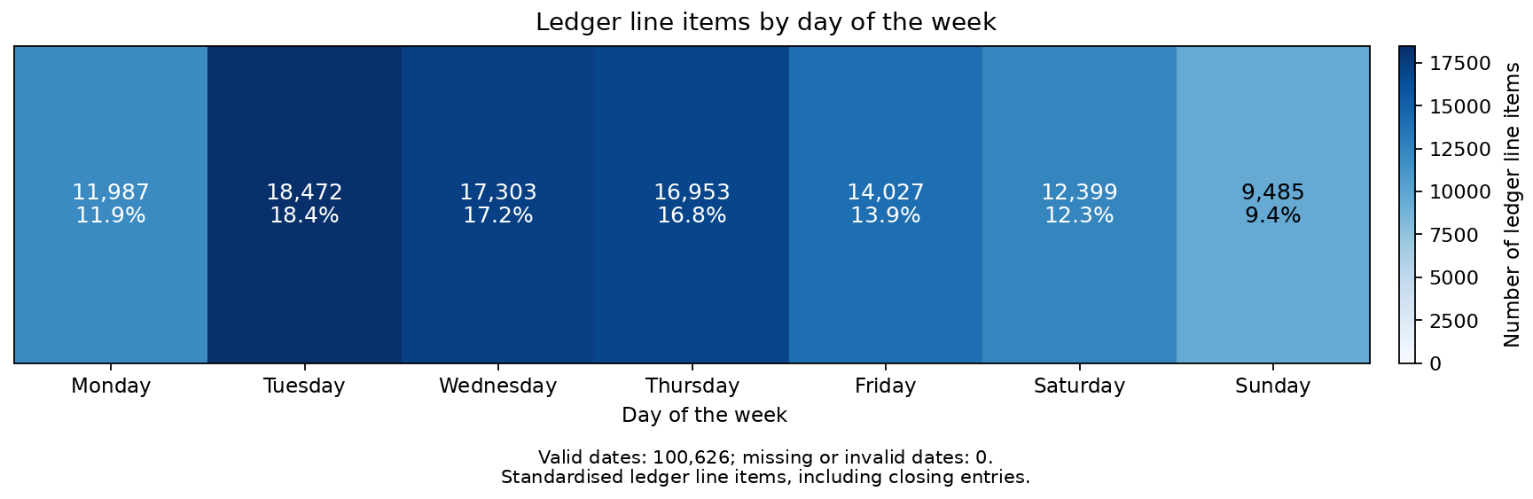
Figure 3.1. Ledger line items by day of the week
The ledger contains 12,399 lines posted on Saturdays and 9,485 on Sundays. Together, these account for 21.75% of the lines analysed, based on the recorded posting dates.

3.2. First-digit analysis using Benford's law
The Benford analysis compared observed first-digit frequencies for positive amounts with the expected distribution. Under Benford's law, the probability of digit d is P(d) = log₁₀(1 + 1/d), giving an expected frequency of about 30.1% for digit 1. Separate tests covered positive debit and credit amounts across the ledger, as well as credits to revenue and income accounts and debits to expense accounts.
Table 3.2. Results of the Benford analysis
Positive-amount dataset | Observations | Chi-square | MAD
Debits across the ledger | 59,896 | 203.5854 | 0.005699
Credits across the ledger | 34,147 | 172.8891 | 0.006998
Credits to revenue and income accounts | 4,375 | 17.1790 | 0.004931
Debits to expense accounts | 39,167 | 163.1976 | 0.006266
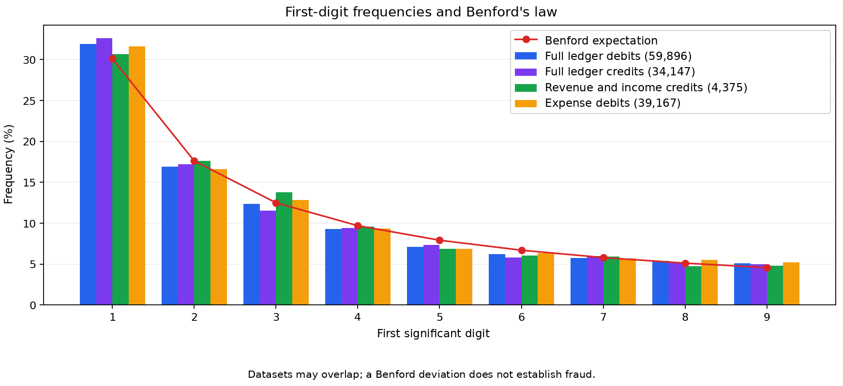
Figure 3.2. Observed and expected first-digit frequencies
Each of the four chi-square statistics exceeds 15.507, the critical value at the 5% significance level with eight degrees of freedom [7]. Under the assignment's mean absolute deviation (MAD) thresholds, two datasets show close conformity and two show acceptable conformity [1]. The chi-square test can detect small deviations in large samples. MAD measures the average absolute difference between observed and expected frequencies.

CHAPTER 4. GENERAL LEDGER AND FINANCIAL STATEMENTS
The analysis reconstructed ledgers for 93 accounts from opening balances and the year's debits and credits. With debit balances expressed as positive amounts, the closing balance equals the opening balance plus debits less credits. The account mapping determines how the resulting figures are classified in the condensed financial statements.
Table 4.1. Condensed balance sheet (VND billion)
Item | Amount
Cash | 15.391
Receivables, net | 60.608
Inventories | 68.713
Other current assets | 47.036
Total current assets | 191.749
Fixed assets, net | 8.898
Other non-current assets | 53.331
Total non-current assets | 62.228
TOTAL ASSETS | 253.977
Current liabilities | 89.919
Non-current liabilities | 0.000
Equity | 164.058
TOTAL LIABILITIES AND EQUITY | 253.977
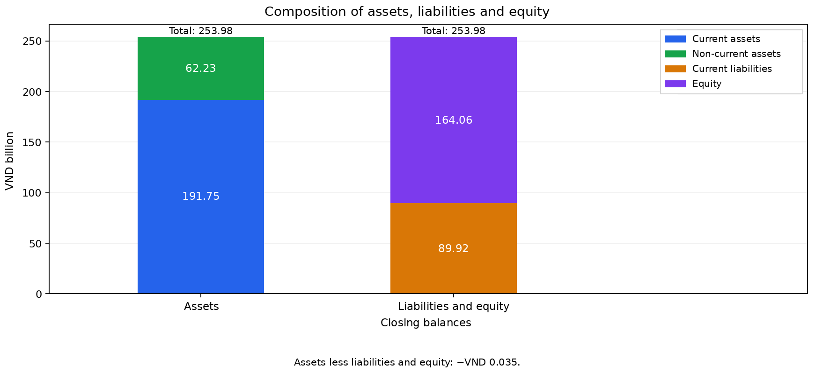
Figure 4.1. Composition of assets, liabilities and equity
Total assets at year-end were VND 253.977 billion, including VND 191.749 billion of current assets. Total assets less total liabilities and equity amounted to −VND 0.035, rounded to three decimal places. The balance sheet shows zero non-current liabilities under the project's maturity assumptions.

4.1. Financial performance and closing entries
Table 4.2. Condensed income statement (VND billion)
Item | Amount
Net revenue | 475.602
Cost of goods sold | 400.313
Gross profit | 75.288
Selling expenses | 48.198
General and administrative expenses | 13.761
Financial income | 2.150
Financial expenses | 4.057
Net profit from operating activities | 11.423
Other income | 0.705
Other expenses | 0.806
Other profit/(loss) | −0.101
Profit before tax | 11.322
Corporate income tax expense per the ledger | 0.000
Profit after tax per the ledger | 11.322
Net revenue of VND 475.602 billion less cost of goods sold of VND 400.313 billion gives gross profit of VND 75.288 billion using unrounded amounts. Net profit from operating activities includes financial income and financial expenses in Table 4.2. Profit before tax was VND 11.322 billion. Profit after tax per the ledger was the same because the ledger contained no corporate income tax expense.
The screening rules identified 450 closing entry lines using account codes and postings against accounts 911 or 421. These lines remain in the general ledger and are excluded from income statement totals to avoid offsetting revenue and expenses. The 131 lines listed for further review overlap with those closing entries.
Receivable and payable movements were aggregated by counterparty where identifiers were available. Calculating closing balances requires the respective opening balances.

4.2. Monthly financial performance
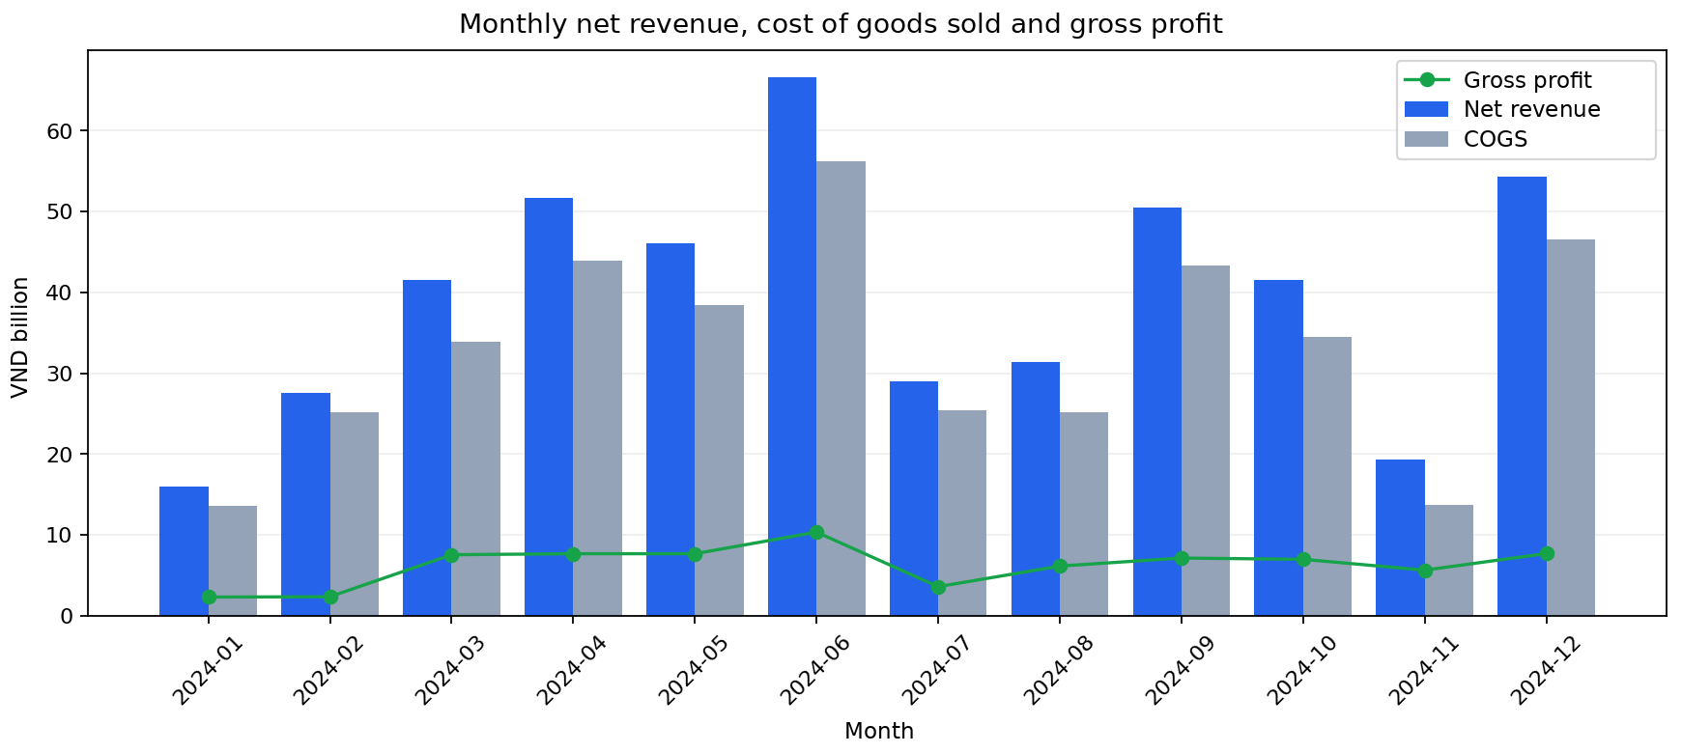
Figure 4.2. Monthly net revenue, cost of goods sold and gross profit
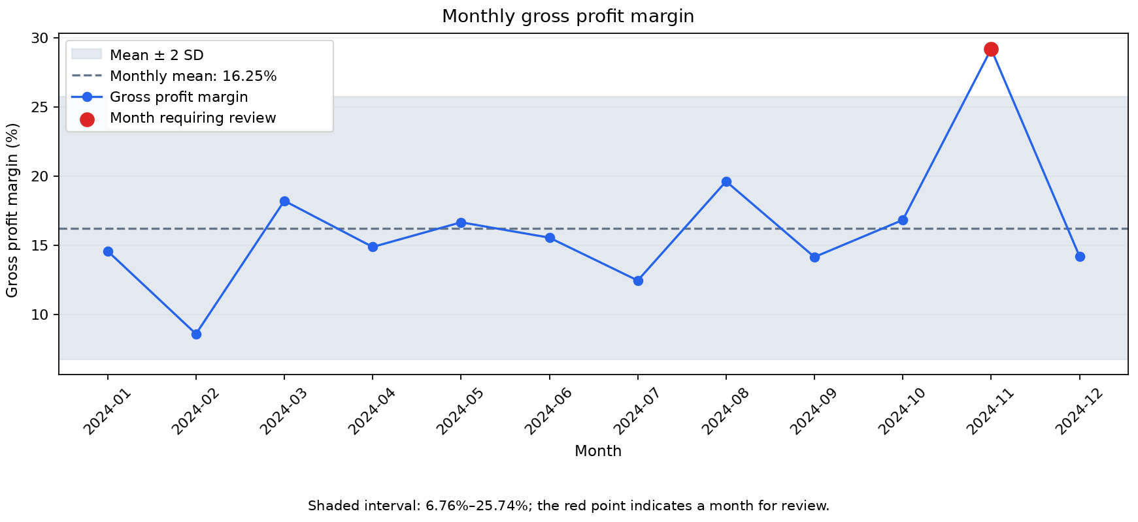
Figure 4.3. Monthly gross margin and reference interval
Gross profit margin is gross profit divided by net revenue. The average of the 12 monthly margins was 16.25%. The reference interval extends two standard deviations on either side of the mean, from 6.76% to 25.74%.
November's gross profit margin of 29.20% exceeded the upper limit. Compared with October, net revenue fell by 53.37% and cost of goods sold fell by 60.30%. Gross profit margin rose by 12.36 percentage points. Excluding adjustment GL24110068 changes the margin by about 0.08 percentage points.
Contracts, documents evidencing customer acceptance, inventory issue slips and product costing schedules are needed to examine the composition and timing of November's revenue and cost of goods sold.

CHAPTER 5. PRELIMINARY MATERIALITY
For audit planning, overall materiality was estimated for the financial statements as a whole. Whether a misstatement could influence users' decisions depends on its amount, nature and circumstances. Table 5.1 compares the benchmarks specified in the assignment with reference to VSA 320 [1, 3].
Table 5.1. Overall materiality under alternative benchmarks
Benchmark | Percentage | Materiality (VND)
Profit before tax | 5.00% | 566,088,772
Net revenue | 0.50% | 2,378,008,349
Net revenue | 1.00% | 4,756,016,698
Total assets | 1.00% | 2,539,769,590
Total assets | 2.00% | 5,079,539,180
The selected benchmark was 5% of profit before tax because Company X was profitable and profit was considered relevant to users of its financial statements. This benchmark yields the lowest overall materiality among the alternatives considered.
Table 5.2. Materiality and the threshold for clearly trivial misstatements
Level | Basis | Amount (VND)
Overall materiality | 5% of profit before tax, rounded down to the nearest dong | 566,088,772
Performance materiality | 50% of rounded overall materiality | 283,044,386
Threshold for clearly trivial misstatements | 3% of overall materiality, rounded down | 16,982,663
Applying 5% to unrounded profit before tax of VND 11,321,775,453.97839645 and rounding down gives overall materiality of VND 566,088,772. The debit and credit imbalances and missing identifiers informed the choice of performance materiality at 50% of overall materiality. The threshold for clearly trivial misstatements was set at 3% of overall materiality, rounded down.
Performance materiality guided the prioritisation of journal entry exceptions by amount. The decision criterion in Chapter 8 compares the overall difference between ledger debits and credits with overall materiality.

CHAPTER 6. FINANCIAL ANALYSIS
Table 6.1 presents 19 financial indicators calculated from the ledgers and condensed financial statements, together with the project's thresholds for the Favourable and Risk ratings [1, 5, 6]. Values between these thresholds are rated Requires attention. Ten indicators were rated Favourable and six required attention. Three were rated Risk, namely the cash ratio, net profit margin and estimated accruals ratio.
Table 6.1. Financial indicators and screening thresholds
Indicator | Result | Favourable / Risk thresholds | Rating
Current ratio | 2.13 times | ≥1.5 / <1 | Favourable
Quick ratio | 1.37 times | ≥1 / <0.5 | Favourable
Cash ratio | 0.17 times | ≥0.5 / <0.2 | Risk
Total liabilities to total assets | 35.40% | ≤60% / ≥100% | Favourable
Total liabilities to equity | 0.55 times | ≤2.5 / ≥5 | Favourable
Interest coverage | 17.36 times | ≥3 / <1 | Favourable
Receivables turnover | 6.89 times | ≥9.125 / <4.5625 | Requires attention
Days sales outstanding (DSO) | 52.99 days | ≤40 / >80 | Requires attention
Inventory turnover | 6.19 times | ≥5 / <1 | Favourable
Days inventory outstanding (DIO) | 58.97 days | ≤73 / >365 | Favourable
Days payable outstanding (DPO) | 23.76 days | ≤30 / ≥90 | Favourable
Cash conversion cycle (CCC) | 88.19 days | ≤60 / ≥120 | Requires attention
Asset turnover | 2.03 times | ≥1 / <0.5 | Favourable
Gross profit margin | 15.83% | ≥20% / <10% | Requires attention
Net profit margin | 2.38% | ≥10% / <5% | Risk
ROA | 4.84% | ≥5% / <0% | Requires attention
ROE | 7.15% | ≥10% / <0% | Requires attention
Altman Z″ | 4.8806 | >2.6 / <1.1 | Favourable
Estimated accruals ratio | −39.06% | Absolute value  ≤5% / ≥10% | Risk

6.1. Liquidity, efficiency and profitability
Liquidity and capital structure
At year-end, current assets were 2.13 times current liabilities. Deducting inventories from current assets gives a quick ratio of 1.37. Cash covered 17.12% of current liabilities. The ability to meet short-term obligations depends on timely collection of receivables and conversion of other current assets into cash.
Total liabilities were 35.40% of total assets and 0.5481 times equity. Both ratios fall within the Favourable range. A change in the split between current and non-current liabilities would affect liquidity ratios, while ratios using total liabilities depend on the combined balance.
Operating efficiency and the cash conversion cycle
Average balances are based on opening and closing balances. Net revenue divided by average trade receivables in account 131 gives turnover of 6.89 times, or days sales outstanding of 52.99 days on a 365-day basis. Cost of goods sold divided by average inventory gives turnover of 6.19 times, or days inventory outstanding of 58.97 days. The turnover calculation uses trade receivables from account 131. Table 4.1 shows net receivables based on the balance sheet account mapping.
Average trade payables divided by cost of goods sold and multiplied by 365 gives days payable outstanding of 23.76 days. Days sales outstanding plus days inventory outstanding less days payable outstanding gives a cash conversion cycle of 88.19 days using unrounded figures. Net revenue and cost of goods sold serve as proxies for credit sales and credit purchases, respectively. Payment terms should be checked when assessing short-term liquidity.
Profitability
For every VND 100 of net revenue, Company X earned VND 15.83 in gross profit and VND 2.38 in profit after tax per the ledger. The annual gross profit margin of 15.83% differs from the simple monthly average of 16.25% because net revenue varies across months. Return on average assets was 4.84% and return on average equity was 7.15%. Each dong of average assets generated VND 2.03 in net revenue.

6.2. Operating cash flow and the accruals ratio
The estimate of net cash from operating activities (CFO) uses 7,976 ledger line items in cash accounts. It provides a basis for comparison with profit after tax per the ledger. The classification uses corresponding accounts, item codes and transaction descriptions.
The project's rules classify collections of trade receivables as operating cash flows and loan principal repayments as financing cash flows. The investing classification covers payments identified by the asset acquisition rules. Transfers between cash accounts and ledger adjustments are tracked separately.
Table 6.2. Reconciliation of changes in cash balances (VND billion)
Component | Amount
Estimated net cash from operating activities | 102.776150
Estimated net cash used in investing activities | −39.155039
Estimated net cash used in financing activities | −68.047137
Net transfers between cash accounts | 0.000000
Adjustments outside the cash flow categories | −0.015261
Unclassified cash movements | 0.000000
NET CHANGE IN CASH BALANCES | −4.441286
Estimated net cash from operating activities was VND 102.776 billion, while cash balances decreased by VND 4.441 billion. Net cash used in investing and financing activities exceeded net cash from operations. The reconciliation separately identifies 15 lines involving account reclassifications, reversals, exchange differences or adjustments to opening balances, including entries classified as opening balances. The unrounded amounts reconcile to the change in cash balances.
Accruals ratio = (Profit after tax − Estimated CFO) / Average total assets
= (11.321775 − 102.776150) / 234.129251 ≈ −39.06%
The ratio is negative because estimated CFO exceeds profit after tax. Its absolute value of 39.06% exceeds the project's 10% screening threshold. The estimate should be reconciled to cash receipt and payment records and to receivables and payables ledgers.

6.3. Interest coverage and the Altman Z″ score
Interest expense was estimated at VND 0.692 billion using the 169 lines coded B29. Adding interest expense to profit before tax gives estimated earnings before interest and tax (EBIT) of VND 12.014 billion. Dividing EBIT by interest expense gives interest coverage of 17.36 times. The item code list and supporting documents should confirm whether B29 identifies interest expense.
The Altman Z″ score uses the four-variable specification provided in the assignment [1].
Z″ = 6.56X₁ + 3.26X₂ + 6.72X₃ + 1.05X₄
Table 6.3. Inputs to the Altman Z″ score
Variable | Definition and inputs | Value
X₁ | Working capital divided by total assets. Working capital equals current assets less current liabilities. | 0.400943
X₂ | Retained earnings divided by total assets. Retained earnings are measured using the net credit balance of account 421. | 0.005142
X₃ | EBIT divided by total assets. EBIT equals profit before tax plus estimated interest expense. | 0.047303
X₄ | Book value of equity divided by total liabilities. | 1.824523
Using unrounded inputs, Z″ equals 4.8806, above the reference safe-zone threshold of 2.6. The assignment classifies scores from 1.1 to 2.6 in the grey zone and scores below 1.1 in the distress zone [1].
Interpreting the score for Company X requires consideration of its industry and the assumptions about liability maturities, retained earnings and interest expense. The short-term liquidity assessment also depends on when liabilities fall due and when assets can be converted into cash (Section 6.1).

CHAPTER 7. DATA VISUALISATION
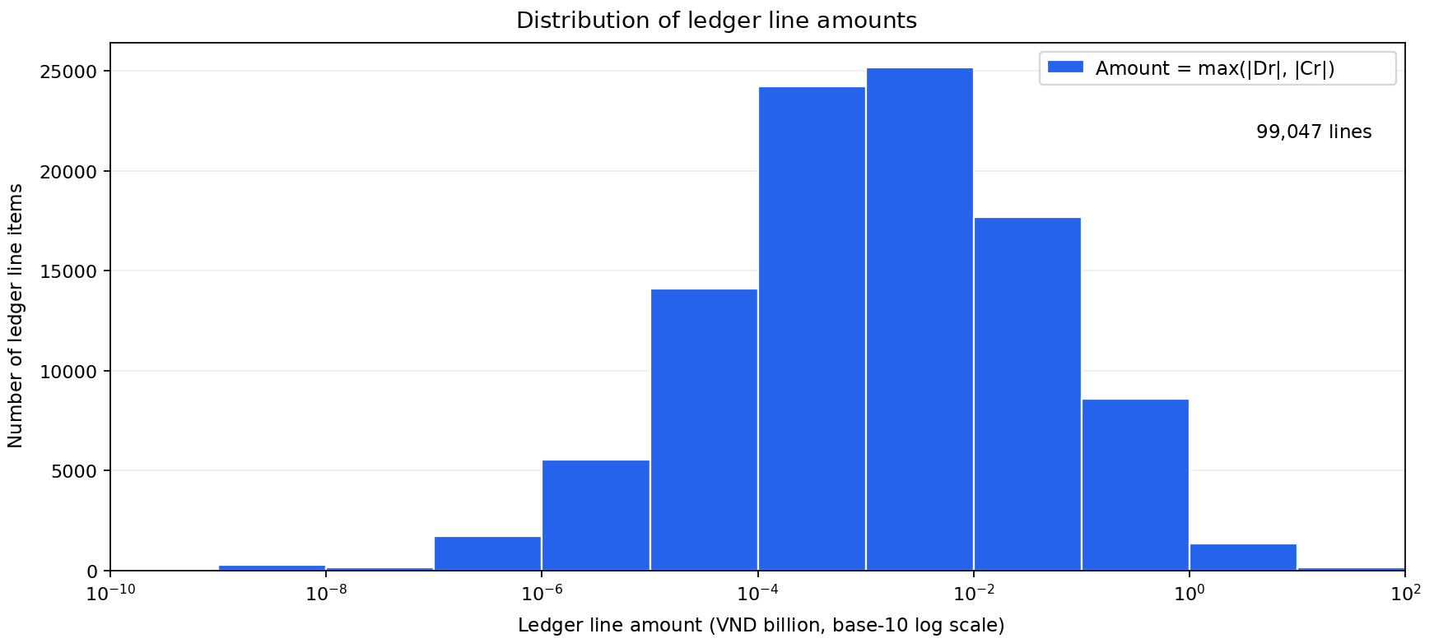
Figure 7.1. Distribution of ledger line amounts
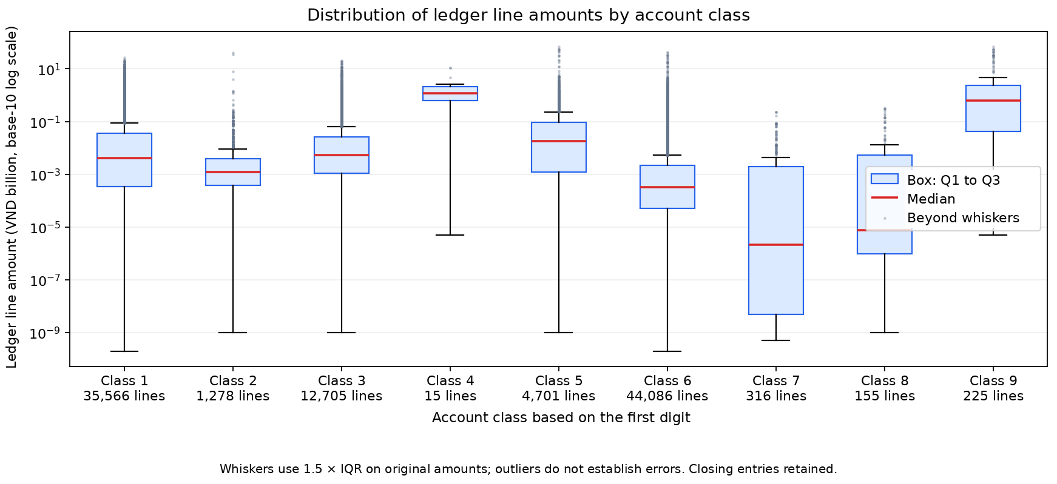
Figure 7.2. Distribution of ledger line amounts by account class
The amount plotted for each ledger line is the larger of its absolute debit and credit amounts. Both figures use 99,047 non-zero lines, including closing entries. The ledger also contains 1,579 zero-amount lines. Each unit on the base-10 logarithmic axis represents a tenfold change in amount.
In the box plot, the red line marks the median and the box spans the first and third quartiles (Q1 and Q3). The whiskers use the 1.5 times interquartile range rule. Points beyond the whiskers identify line items whose supporting documents can be selected for review.
The dashboard.html file contains nine charts. It supports value lookup, filtering and zooming offline. Charts on the timing of entries use the recorded posting dates.

CHAPTER 8. AUDIT CLIENT ACCEPTANCE ASSESSMENT
Each of the five risk categories is scored on a scale from 0 to 100. Higher scores indicate higher assessed risk. The weighted sum determines the recommended acceptance decision under the project's rules.
Table 8.1. Risk scores, weights and contributions
Risk category | Score | Weight | Contribution
Data quality and integrity | 50 | 15% | 7.50
Journal entry testing | 70 | 30% | 21.00
Financial condition | 50 | 30% | 15.00
Financial reporting risk | 50 | 15% | 7.50
Qualitative factors | 50 | 10% | 5.00
TOTAL |  | 100% | 56.00
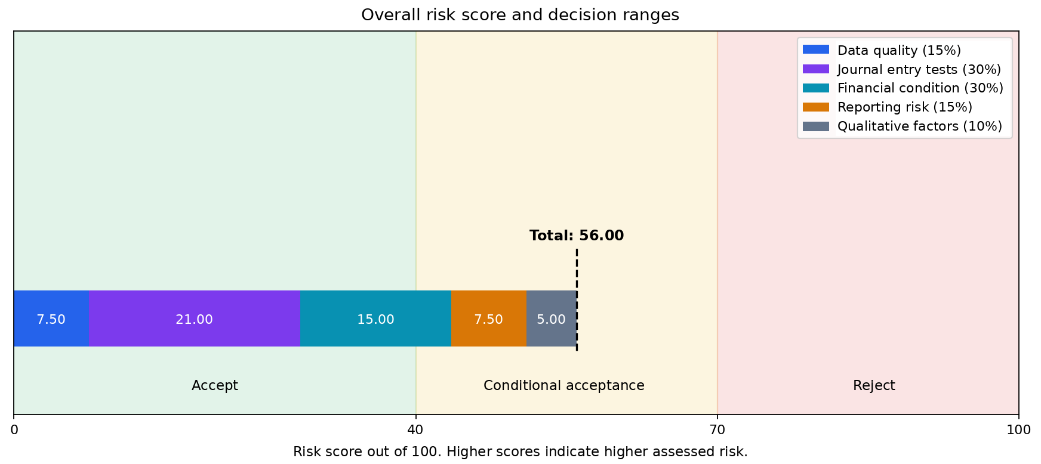
Figure 8.1. Overall risk score and decision ranges
Journal entry testing contributed 21.00 points, the largest of the five contributions. The overall score was 56.00 out of 100. A score below 40 leads to a recommendation to accept the engagement. Scores from 40 to below 70 lead to conditional acceptance, and scores of 70 or above lead to rejection.
The journal entry score is the mean of the scores for the ten procedures. The financial analysis score averages the highest risk score in each of the five indicator groups to limit double counting of related indicators. The profitability group already scores 100, so the Risk rating for the accruals ratio adds no further points.

8.1. Decision override criteria and sensitivity analysis
The project applies two decision override criteria in addition to the overall score. Meeting either criterion requires at least conditional acceptance, including when the overall score is below 40.
Table 8.2. Assessment of the decision override criteria
Decision override criterion | Assessment | Status
Difference between total debits and credits above overall materiality | The absolute difference of VND 0.03507850 is below overall materiality of VND 566,088,772. | Not triggered
Confirmed fictitious revenue exceeding overall materiality | Verification is pending on whether fictitious revenue was recorded and on the amount of any resulting misstatement. | Pending verification
The difference between total ledger debits and credits was below overall materiality. The criterion for fictitious revenue is pending verification. The preliminary recommendation is conditional acceptance.
The sensitivity analysis covers 15 scenarios, including the baseline. Each weight or decision threshold was tested at 20% above and below its baseline value. In scenarios that change a weight, all weights were rescaled to sum to 100%.
Table 8.3. Sensitivity analysis across 15 scenarios
Scenario group | Score | Recommendation
Baseline (1) | 56.0000 | Conditional acceptance
Each weight changed by ±20% (10) | 55.1064–56.7925 | Conditional acceptance in all cases
Threshold of 40 changed to 32 or 48 (2) | 56.0000 | Conditional acceptance
Threshold of 70 changed to 56 or 84 (2) | 56.0000 | Rejection at 56. Conditional acceptance at 84.
The recommendation remained conditional acceptance in all ten weight scenarios, with scores from 55.1064 to 56.7925. Reducing the rejection threshold from 70 to 56 changed the recommendation to rejection because 56 equals the baseline score.

8.2. Conditions for acceptance and proposed audit procedures
Table 8.4 sets out the information required for approval and the proposed procedures if the engagement is accepted. The auditor responsible for the engagement reviews how each requirement has been addressed before seeking approval.
Table 8.4. Required evidence and audit procedures
Code | Required evidence or action | Timing and responsibility
A01 | Complete the acceptance file. Agree on the scope, staffing and fees appropriate to the assessed risk. | Audit firm management, before signing.
A02 | Obtain missing voucher numbers and the chart of accounts. Explain reconciliation differences and confirm the scope of exported data. | Client and audit team, before finalising the scope.
A03 | Obtain supporting documents for unbalanced vouchers, possible duplicates and other high-priority exceptions. | Investigate significant exceptions before approval. Continue testing during the audit.
A04 | Obtain liability maturity schedules and cash records to verify liability classification, interest expense, estimated CFO and inputs to the Altman score. | Client and reviewer, before approving assumptions.
A05 | Explain November's gross profit margin. Examine documents evidencing customer acceptance, costing schedules and early 2025 records for cut-off testing. | Experienced staff, during planning and fieldwork.
A06 | Verify the industry, governance arrangements and management integrity using corroborating evidence. | Auditor responsible for the engagement, before approval.
A07 | Obtain evidence to investigate possible fictitious revenue and quantify any confirmed misstatement. | Auditor responsible for the engagement, before the final decision.
A08 | Explain the selection of thresholds 40 and 70, and assess the outcome when the rejection threshold falls to 56. | Audit team and reviewer, before approving the recommendation.
Before approval, the firm assesses independence, conflicts of interest, the engagement team's competence and the preconditions for an audit under VSA 210 and VSA 220 [3]. If the firm accepts the engagement, the audit plan should include cut-off testing, external confirmation of receivables and payables, and attendance at physical inventory counts. Experienced staff should review the journal entry exceptions given high priority.

CONCLUSION
The 43 top-level accounts reproduce all six totals within the client trial balance; period debit and credit totals from the detailed ledger retain very small differences from that reference. Reconciliation by voucher and by account identifies issues that require follow-up. Two vouchers posted at the start of the year have substantial differences between debits and credits. Potential duplicates, missing identifiers and balance differences need to be checked against the original records.
Company X recorded a profit and total liabilities represented 35.40% of assets. Cash covered 17.12% of current liabilities, and net profit margin was 2.38%. November's gross profit margin and the estimated accruals ratio of −39.06% require further review during planning. The analysis covers one financial year. Interpretation depends on liability maturity schedules, opening balances by counterparty, and evidence supporting cash flow classifications.
The risk score of 56.00 out of 100 supports conditional acceptance under the project's rules. Before approving the engagement, UEL-Audit should investigate possible fictitious revenue, resolve exceptions that could give rise to material misstatements, and assess the firm's independence and capacity as well as the integrity of Company X's management.

REFERENCES
[1] Course instructor. (n.d.). Audit.py—A system for assessing audit client acceptance [Group assignment for Data Analytics in Accounting and Auditing].
[2] Ministry of Finance. (2014, 2016). Circular 200/2014/TT-BTC on the corporate accounting regime and Circular 53/2016/TT-BTC amending and supplementing Circular 200/2014/TT-BTC. Circular 200/2014/TT-BTC; Circular 53/2016/TT-BTC
[3] Ministry of Finance. (2012). Circular 214/2012/TT-BTC promulgating the Vietnamese Standards on Auditing. Standards referenced in the assignment include VSA 210, 220, 240, 315, 320, 520 and 570. Source
[4] Ministry of Finance. (2025). Circular 99/2025/TT-BTC on the corporate accounting regime (Article 31, paragraph 1). Source
[5] Business Queensland. (n.d.). Financial ratios and calculators. Source
[6] Business Development Bank of Canada. (n.d.). Debt-to-equity ratio calculator. Source
[7] NIST/SEMATECH. (n.d.). Critical values of the chi-square distribution (Section 1.3.6.7.4). In e-Handbook of Statistical Methods. Source

APPENDIX A. OUTPUT FILES AND REPRODUCIBILITY
Table A.1. Output files by module
Module | Files in outputs/ and their contents
1. Data integrity | 01_data_integrity.xlsx records row counts, period coverage, missing fields, debit and credit checks and source reconciliations.
2. Journal entry testing | 02_je_findings.xlsx records the ten procedures, priorities, source row references and Benford results.
3. Ledgers and financial statements | 03_ledger_statements.xlsx contains account ledgers, the trial balance, condensed financial statements and monthly results.
4. Financial analysis | 05_financial_analysis.xlsx contains 19 financial indicators, thresholds, inputs, estimated CFO and analyses of months requiring explanation.
5. Materiality | 04_materiality.xlsx records the alternative benchmarks, selected basis and three monetary thresholds.
6. Visualisation | The charts/ directory contains nine charts. The dashboard.html file provides interactive charts and tables for offline use.
7. Client acceptance | 06_acceptance_sensitivity.xlsx records risk scores, decision override criteria, 15 scenarios and eight groups of actions.
Table A.1 lists the modules in the order specified by the assignment. The workflow calculates materiality before using it to prioritise journal entry exceptions. README.md contains the setup instructions, and main.py runs the analysis.
Each run has a unique identifier. The audit_log.jsonl file records each processing step, its timestamp, input and output counts, and execution status. The Run_Log worksheet in the journal entry output file records the ten screening procedures.
Commands to run from the project directory
python3 -m pip install -r requirements.txt
python3 -m pytest -q
python3 main.py
The project records indicate that this version passed 329 tests.

APPENDIX B. SOURCE CODE ORGANISATION
The code uses object-oriented programming (OOP) for ledgers, trial balances and testing procedures, and functional programming (FP) for standardisation, filtering and ratio calculations. Table B.1 summarises the techniques used.
Table B.1. Programming techniques used in Audit.py
Object-oriented programming (OOP) | Functional programming (FP)
Classes and __init__: construct GeneralLedger and TrialBalance objects. | Pure functions: accept inputs and return ratio results.
Encapsulation and properties: expose totals without directly modifying source data. | lambda: defines concise sorting keys for results.
Inheritance: both data loaders extend BaseLoader. | map and filter: transform and select ledger line items.
ABC and abstractmethod: specify methods that subclasses must implement. | reduce: totals debits and credits.
Polymorphism: invokes a common method across different testing procedures. | Higher-order functions and closures: create filters bound to a threshold.
Frozen dataclasses: prevent reassignment of fields in records and results. | Decorators record execution with audit_log and register ratios with register_ratio.
Dunder methods: support ledger iteration, line counts, trial balance merging and priority ordering. | partial: creates a test with a fixed round-number base.
classmethod and staticmethod: construct objects from configuration and round amounts. | Generators and yield: supply ledger line items sequentially.
Enum: gives risk levels and decisions consistent names. | itertools: accumulates values and combines data sequences.
Composition: AuditEngagement contains the client, ledger and procedures. | Pipelines and pipe: connect standardisation steps in sequence.
Custom exceptions: SchemaError reports structural problems. | Immutability: uses tuple, frozenset, frozen dataclasses.
Factory, Strategy and Registry: select loaders, procedures and ratios. | Comprehensions: construct lists, sets and result mappings.
The auditpy/ directory separates data loading, validation, ledger construction, calculations and visualisation. Tests use small datasets, including missing or malformed records, to check program behaviour.

